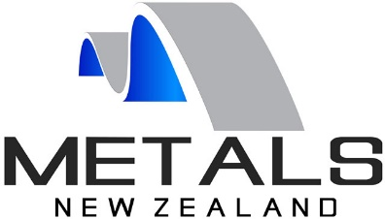
Metals New Zealand

Oral submission to the Environment Select Committee on the Climate Change response (Zero Carbon Bill) Amendment Act

Nick Collins, CEO Metals New Zealand

19 August 2019

Members of the Select Committee, good morning and thank you for the opportunity to present to you.

I will be brief, because you will all have read our submission and I am interested as to what questions you have.

About us

Metals New Zealand is the pan industry Metals sector organisation which represents the seven individual member organisations

HERA – the Heavy Engineering Research Association – established in the 1980’s HERA has over 680 members and is responsible for research into essentially heavy steel solutions for manufacturing, infrastructure and construction

Steel Construction New Zealand – SCNZ with over 400 members drawn principally from engineering consultancies and heavy steel fabrication. SCNZ, along with HERA have been at the leading edge of seismic resilience in engineering design, which has resulted in almost all of the Christchurch CBD rebuild being constructed from fabricated steel.

Other Metals members include MRM (Metal Roofing Manufacturers), NASH (the National Association of Steel framed housing), Stainless New Zealand, the Aluminium Extruders of New Zealand and Casting Technology NZ.

Also included in our membership are large corporates engaged in Metals manufacturing – New Zealand Steel, Fletcher Steel, Pacific Steel and Steel & Tube. Some of whom you have already heard from.

It is these member organisations and corporates who have brought together the Sustainable Steel Council with a focus on assisting our small to medium sized businesses in the transition to a circular and low emission economy.

Our submission

Why you might ask are these Metal sector organisations so critical to New Zealand’s transition to a circular and low emission economy?

In summarising the key elements made in our submission, that the New Zealand Metals sector is critical to New Zealand’s transition to a circular and low emission economy’ I just want to focus on three key issues.
- Firstly, the Metals sector is a significant contributor to jobs and GDP, particularly jobs in regional economies
- Secondly, as with other manufacturing sectors - Metals Manufacturing needs a fair playing field to maintain, grow and innovate.
- Thirdly, steel and aluminium are the ultimate Circular Economy - Ōhanga āmiomio, materials, generating minimal waste through the supply chain, easy to reuse and repurpose and infinitely recyclable. Progress is being made to reduce emissions and to support small / medium businesses on the journey to a circular low emission economy… but for New Zealand that transition won’t happen quickly without steel and aluminium. The investment required to transition to low-emissions, climate-resilient infrastructure, transport, energy and housing / built environment relies heavily upon New Zealand Metals manufacturing.

Firstly, Metals manufacturing is a significant contributor to employment – over 29,000 jobs in manufacturing (this excludes the thousands of employees and contractors across building, construction and infrastructure). Jobs in Metals manufacturing are generally highly skilled, paying well above average rates of pay with high levels on ongoing trades training.

MBIE’s 2018 manufacturing sector report identified that Metals manufacturing contributes over $3.3bn to the NZ economy.

Regional economies like Taranaki and Hamilton rely heavily on Metals manufacture – for example Hamilton is the second largest aluminium processing centre in the southern hemisphere – hosting three of New Zealand’s four largest extruders, with significant upstream and downstream support industries such as tool making, painting, anodising and window manufacture along with future commitment of over $16m future investment in glass manufacturing. In the Waikato alone this segment is estimated to contribute over $1bn annually… from raw material to boat building, windows, transport and infrastructure.

Secondly, to affect a rapid transition to a circular and low emission economy New Zealand manufacturing needs a fair playing field…

Fair, with respect to imported products, which are generally purchased because of cheaper capital cost and where we frequently have little or no information on the product stewardship, manufacturing energy sources, environmental impacts of material extraction, water use, labour relations and of course embodied carbon.

Construction of New Zealand’s built environment has been plagued by delays of sub-standard imported products and materials (Novatel in Christchurch and Alexandra Park in Auckland being years behind schedule).

Owners of some recently built buildings are facing significant refurbishment costs owing to failure of cheap imported building facades (eg Mainzeal buildings, constructed in the last decade where the facades which were imported from China are now leaking badly).

We need fairness and equity relative to other sectors of the New Zealand economy. There are over 3,000 employees in MPI serving the needs of our primary sector. The MBIE has a manufacturing team of 3 or four people.

MPI have a programme on regenerative agriculture. They are setting up an advisory service for farmers to assist in their transition to a lower emission pastoral sector…

Significant funds are invested in research into primary sector… 80% of those funds come from the crown.

By contrast research into manufacturing sector, while significant, is much lower… and 80% of that comes from manufacturers themselves.
- Where then is the support for manufacturing to transition to a circular and low emissions economy?
- Where is the government investment in the building sector to build regenerative buildings (we have the technology)?
- Where is the equity in government’s funding programmes for all sectors of our economy to make the transition?
- Why has the New Zealand Government support favoured export orientated, principally pastoral, enterprises, which generally provide low value jobs and produce over half of New Zealand emissions along with significant negative impacts upon our water quality?

My third and final point is that steps are being taken across the Metals sector to transition to a circular and low emission economy, and metals is critical to a successful transition to the circular and low emission economy for New Zealand. …

For some it is extremely difficult, for others it is more straight forward

An example is the production of carbon steel, so-called because it involves a chemical process of turning iron into steel. As pointed out by the Climate Change Minister James Shaw on a number of occasions, globally, no one yet as a commercially viable technology to make steel without carbon. There is positive progress being made in Sweden, where three state corporations, (an energy generator, minerals business and steel company) are collaborating to research and develop technologies which hopefully will result in the production low emission steel. They aim to have a trial plant underway by 2030.

For those of you who don’t know, turning iron sand into iron is a process unique in steel making to New Zealand, we are the only country where there is a dedicated steel plant making steel from iron sand and the technology was developed in New Zealand.

I would argue that had New Zealand’s steel sector been the beneficiary of continued Crown investment in steel making, with even a fraction of the investment we have seen into research into our pastoral sector, we could have, and could still be, a pioneer on the journey to low emission steel.

Without a vibrant local manufacturing sector New Zealand will lack the capability and capacity to successfully innovate to develop new low emission technologies to aid New Zealand on the journey to a circular and low emission economy.

For example, the Lanzatech technology to trap emissions from steel making and convert them to a methanol, thereby producing a low emission energy source was originally hosted at New Zealand Steel’s Glenbrook plant.

What we’re doing

New Zealand Steel is committed to reducing emissions, targeting a 1% reduction per annum.

New Zealand Steel’s progress on recycling scrap has been significant in recent years, up from recycling 70,000 tonnes three years ago to 120,000 tonnes in the last year – 18% of its current steel production, significantly extending the life of the raw material stocks.

The plant is also operated to high environmental standards with ISO certification, Environmental Product Declarations and reuses or sells around 80% of its co-products - including generating around 60% of its energy on-site from off gases

At the other end of the Metals value chain we have an engineering business in Nelson, Kernohan Engineering, have become certified carbon zero over the last year working to reduce their emissions where possible and then to offset those remaining emissions, principally from freight and travel where Kernohan are limited in their ability to influence. Key drivers for Kernohan have been early mover advantage in a market increasingly seeking low-emission product, the cost-efficiencies and wanting to show leadership to other businesses.

Finally, in the transition to a circular, low emission economy New Zealand needs local metals manufacturing, to successfully transition by 2030 / 2050.

New Zealand needs to invest significantly in infrastructure, renewable energy, transport and housing – all of which will continue to rely on high strength metals. Metals continues to lead in the design and fabrication of structures resilient to seismic and fire.

Far better for New Zealand that we transition to a circular and low emission economy using high quality New Zealand metals whose footprint we can trust, supporting high-value jobs and manufacturing businesses which continue to be the backbone of our regional economies.

So, in summary for New Zealand to successfully transition to a circular economy
- New Zealand needs to continue to rely a vibrant Metals manufacturing sector which delivers high value jobs in our regions, and continues to be a significant contributor, not just to GDP but across all four capitals of the Living Standards framework.
- to succeed local manufacturing needs a fair playing field, particularly, in the face of cheap imports of doubtful quality and unknown stewardship
- and finally, the sector is making progress, Metals manufacturers are a critical component of the transition to a circular and low emission economy and government needs to develop a more equitable framework to facilitate Metals manufacturing to enable New Zealand’s transition to a circular, low emission economy as speedily as possible.

Thanks you for your time. Happy to answer any questions.

New Zealand
Metals Industry is critical
to the transition to a circular and low emission economy
Considerable size and importance | Need a fair playing field for domestic manufacturers | Steps are being taken, but in the meantime, metals are essential to deliver new infrastructure, renewable energy and dwellings to house New Zealanders
29,000 jobs, majority of which are highly skilled and well paid  $3.3bn contribution to GDP | Fair in comparison to imports  Fair in comparison to other sectors of the economy  Imported product not subjected to same carbon costs as local manufactured costs.  Local product has clear stewardship… environmental, H&S standards, employment practices are high.  We don’t know about majority of Metal imports | New Zealand Steel production – 660,000  Waste recycling – 120,000 up from 70,000 tonnes three years ago.  Re-forming of SSC  Focus on giving small / medium sized business the tools to transition their businesses

Dr Duncan Webb | 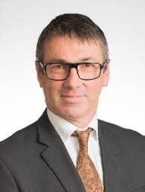

MP for Christchurch Central
Duncan Webb brings broad experience to Parliament. He was a partner in a major law firm, and prior to that a professor of law. His credentials as a social activist are unquestionable – since 2010 he worked to help ordinary people in Christchurch get their homes, lives, jobs, and businesses back on track after the earthquakes. He was an advocate for an inquiry into the failings of EQC.
Scott Simpson, | 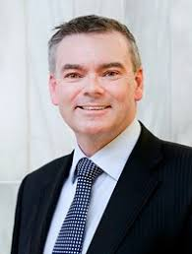

National Coromandel

Spokesperson for Climate Change
He was elected at the 2011 general election with a majority of 12,740.^{[1]}

Dr Liz Craig | 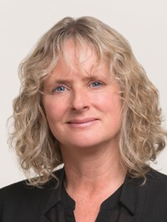

Labour List MP

Before entering Parliament Liz was public health doctor, working for over a decade to monitor the health of New Zealand’s children and young people. In that time, she saw how years of chronic under-investment had played out in the lives of many. One in five children were living in poverty, with thousands being hospitalized each year for poverty-related diseases.

Sarah Dowie

National MP, Invercargill
Sarah Dowie is an ex-lawyer, environmentalist and the first female Member of Parliament for Invercargill. Elected in 2014 she is the Opposition Spokesperson for Conservation – a role she loves!
After graduating from Otago University with a Bachelor of Laws and Science she was admitted to the Bar in 1998, before establishing a successful career practicing commercial and environmental law.
She is a former manager for the Department of Conservation in its tourism and concession wing and is now a trustee and Deputy Chair of the Dog Island Motu Piu Conservation Trust, which is working to eradicate pests on the island and restore it as a viable habitat for tuatara.
Sarah is a busy mum to two school aged children. She spends half her time up in Wellington representing the views of the region at the Beehive and the other half in the electorate she is fiercely proud of. Instinctively community-minded, Sarah was an appointee to the Otago-Southland Lotteries Board and also provided free legal services to Venture Southland and sporting and conservation groups. She has organised the free, family event – MAD Day Out for the last three years and was a celebrity dancer for the 2016 Ronald McDonald Family Room Southland fundraiser Rocking with the Stars.

Nathan Guy |  | 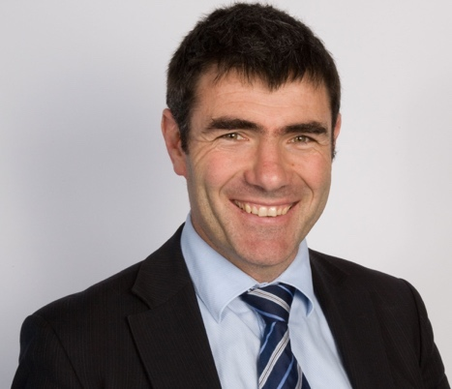

National Party, Otaki
Guy is a farmer from near Levin. He has been involved in various agricultural sector trusts and councils, and studied farming at Massey University. He served eight years on the Horowhenua District Council from 1998 to 2005.^{[2][3]}
Nathan Guy is the MP for Otaki and was honoured to be a Minister in the National Government from 2009 to 2017.
Jenny Marcroft |  | 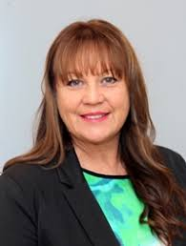

NZ first List
New Zealand First List MP based in Rodney, Spokesperson for Health, Broadcasting, Human Rights, ACC, Conservation and Environment
Marcroft had a career spanning over 30 years in the broadcasting industry, mostly reading the news on the radio for Independent Radio News, however she also read the news on television for TV3 at times.^{[2]} During her career she worked to ensure her pronunciation of Māori names was correct, receiving criticism for doing so. During the 1990s as a newsreader she was told not to say "kia ora" at the beginning of bulletins, but decided to persist anyway.
Erica Stanford |  | 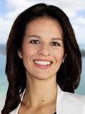

National East Coast Bays
Born in the East Coast Bays,
After attending Rangitoto College, I went on to complete a Bachelor of Arts with First Class Honours at the University of Auckland.
I have worked in a number of export sales roles for New Zealand manufacturers, and have produced a range of local television shows, including Piha Rescue.

Cloe Swarbrick

Green Party List

Spokesperson for Mental Health, Drug Law Reform, Education, Arts and Heritage, Tertiary Education, Small Business, Broadcasting, Youth, Local Government.
Chlöe grew up in an Auckland family who raised her on a diet of robust and challenging discussion, and in a community that showed her that inequality and injustice were a daily reality for too many New Zealanders.

Angie Warren-Clarke |  | 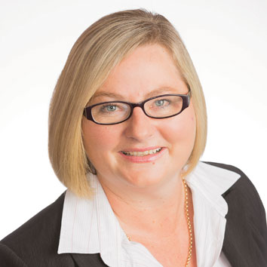

Labour list, based in BoP
Angie Warren-Clark has many years experience working in government, and has worked as the manager of Tauranga Women’s Refuge. She was admitted to the Bar in 1998 as a barrister and solicitor of the High Court of New Zealand and also holds a degree in Social Sciences.
Angie believes that the Bay of Plenty has been struggling with increased homelessness, home and rent affordability, an underfunded and overstretched health system, and an education system that is no longer a world leader.

